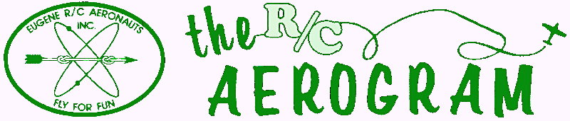

Volume 4 Issue 5 AMA #530 District 11 www.eugenerc.com May 2008

Club Mailing Address: Eugene R/C Aeronauts, PO Box 26344, Eugene, OR. 97402

ERCA News and Information

Next CLUB Meeting – May 27, 7:00 pm at EWEB. Meetings for June, July and August will be held at the field. If you have a building project, bring it with you for "Show and Tell".
At the April Meeting – There were 24 members and guests at the meeting.
A new member, Dan Leon, was welcomed into the club.
The BIG Bird Fly has been rescheduled for June 14th, 2008. July 19th was selected for a backup if the elements intrude. The same format and prizes will be utilized.
Our annual FUN Fly has been scheduled for August 16th and 17th, 2008.
The new and updated constitution and bylaws were discussed and approved by majority vote. Check the website for details.
Show&Tell – Brad Werneth brought his Hirobo EVO helicopter powered by an O.S. .50sx Hyper glow engine.
Our PO Box has changed to: P.O. Box 26344, Eugene, Or 97402. Any OFFICAL ERCA mailings should be sent to this mailing address.
Budget talk: There have been some email discussions about field improvements and budget items. Expect more on these subjects at the May meeting.
CARL HENSON FIELD – The field was mowed once each week, if the sun starts showing up more often, the mowing will need to be more frequent. Rumor has it that we may be watering before the end of May.
The pump has been connected to the well and it and the sprinkler system have been tested.
Another small piece of mat was nailed down in the area between the wind sock pole and the club house. There is a good possibility that we will be adding fertilizer to the runway before the end of May.
There is a drawing on the club house bulletin board of the "designated flying area", PLEASE look it over.
NEWSLETTER NEEDS INPUT – Thank you Brad Werneth for your input.

I would like members to send me photos and a short write-up on any projects they are working on, or new aircraft. If you can’t email it to me, mail me a photo and a note.

Also if you have any building TIPS or TRICKS you would like to share, I would be glad to pass those along.

Meeting minutes are ONLINE at: http://erca.home.comcast.net/%7Eerca/Meetings.html

BIG BIRD FLY-IN


Eugene R/C Aeronauts

present ...

Big Bird Fly-In fun!

Everyone invited — No entry fee!

Saturday, June 14, 2008

• Bring any and all airplanes ... do any kind of flying!

• Every flight gets an entry in the “flying raffle”

• Flying raffle prizes will be awarded after a drawing
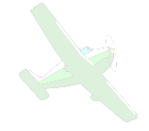
• Club Sponsored BBQ

Contact: Pat Willis - 541-543-8999 p-willis@msn.com for information.

Academy of Model Aeronautics membership required

SHOW & TELL

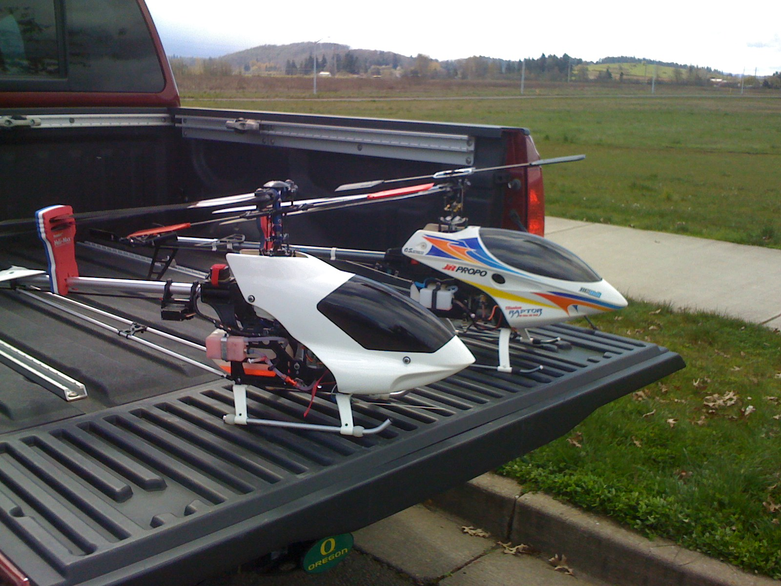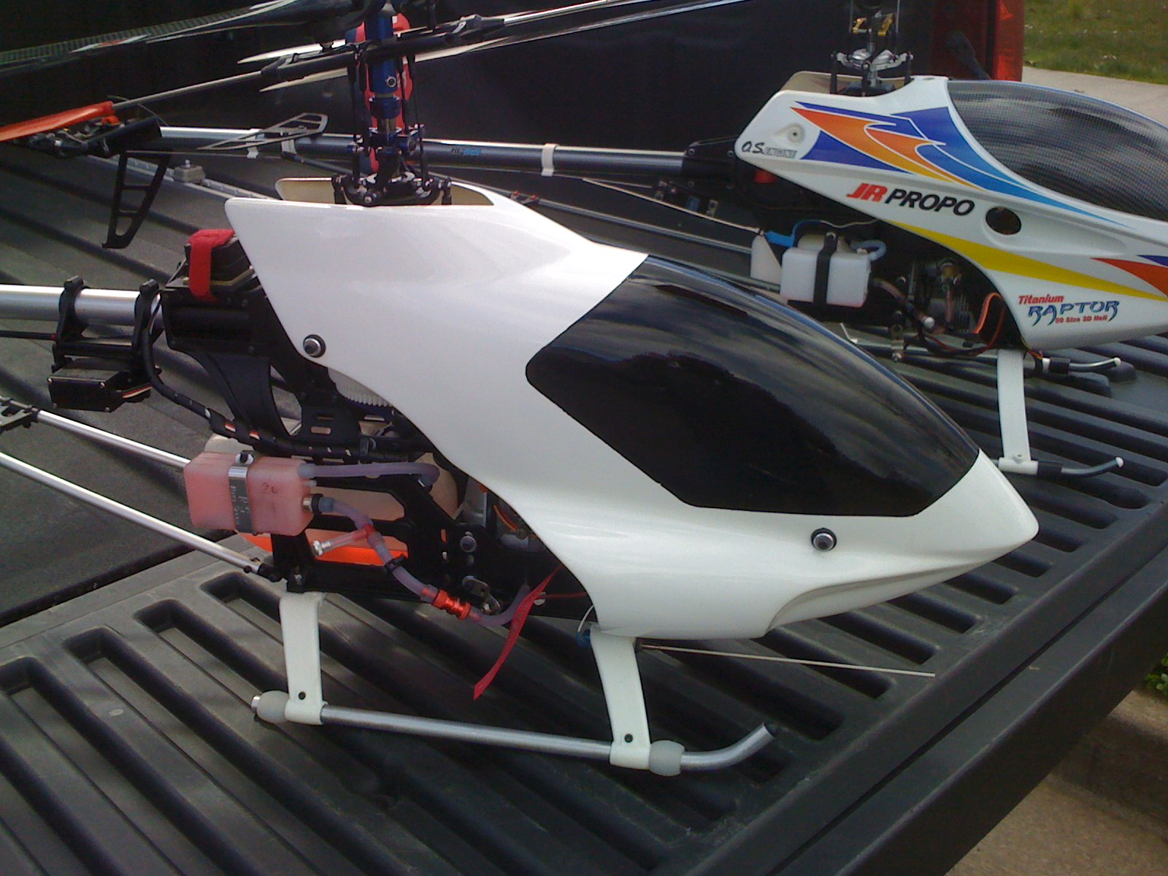

Brad Werneth brought his Hirobo EVO helicopter powered by an O.S. .50sx Hyper glow engine.

Treasurers Corner

2008 Mar 87 members are confirmed current with AMA and ERCA.
3 new members joined this month.
Thanks to everyone for their prompt renewals.
2008 Apr 92 members are confirmed.
1 new member has joined.

Our PO Box has changed to: P.O. Box 26344, Eugene, Or 97402.
Any OFFICAL ERCA mailings should be sent to this mailing address.

KUDOS

A BIG thanks to Marty for the refirbished “10 MPH” sign.

WHATS NEW

South Lane R/C has a new web site, check it out! http://www.southlanerc.net/
Flight tables by Jeff Engel.

Presidents Corner

The nice flying weather is upon us. Some of these overcast days are the best, when there is little to no wind and it's not too hot or too cold! I'm thoroughly looking forward to getting some serious flying in during the fair weather flying season. I flew my 29% Giles G202 the other day and had a blast, even though, (as a few witnesses will tell you) I almost crashed it getting a little too confident. Sometimes it's nice to fly the one that has been collecting dust. I remembered exactly why I liked that plane so much last summer. My little T-Rex 450 actually flew 5-6 times in one day. I almost crashed that one too, but it also made it back in one piece.
And, then there's the sad T-Rex 600N that for some reason can't seem to stop wagging its tail. Unlike a puppy, it's not wagging the tail out of joy, but out of discontent for some unknown reason. I've been chasing the problem for about 2 months now, and no matter what I try, I can't seem to fix it. My most recent attempt was to decrease vibration in the airframe by replacing the bearings in the O.S. .50 engine. I never knew how easy it was to replace the bearings and really make the engine purr. The old bearings had a gritty feel when I took them out, and the rear bearing was really rusty. This engine is actually only about a year old and has seen after-run oil many times. The piston and liner were both very varnished and the crankshaft had rust spots. After an overhaul, the engine was running very quietly and happily; however, the tail was not as content. Alan Wellentin, (now an official field rep for Dee Tee Enterprises) is going to help me figure it out.
Al recently came up with a budget for 2008 listing all of our expenditures, and it's more clear now than ever that we need to be very cognizant of our spending. Gasoline to run the irrigation pump is going to be very costly this summer. The driveways are going to need a few loads of gravel. Our landlord will want to be paid. When the end of the year comes, we are most likely going to have less than $2000 if things continue the way they are. Why, you ask? Well, last year we had a sudden influx of new members, each paying that handsome one-time field improvement fee of $100. This year, we will probably not have that many new members. So, with that in mind, my recommendation is that we continue to be somewhat frugal with our funds. As much as I would like to have a new clubhouse with a solar panel assembly and running water, it just is not within our financial means. For now, I think our services are pretty darn good considering we pay $5 per month to be members, (okay, as the Pres, I don't pay, but I make up for it!!).
We really need to save up our funds for the unexpected. Any day now the rug could be yanked out from under us, and we could find our club in a very bad position. I've had one person threaten to sue us already this year, (the suit was without merit, but still...) and we need to be prepared by maintaining a substantial emergency fund for the "what if..." scenarios that we could face in the future.
Those of you that want more services from your club may not like what I have to say now, but in a few years if/when an emergency need comes along, you may be very happy that I made the recommendation to SAVE SAVE SAVE our precious funds for the future.
Now, I have some good news on the glow fuel front: Eugene Toy and Hobby is going to start stocking Cool Power 30% Helicopter fuel. This is great news for all of you that have helicopters, (yeah, I know that's only a handful of you, but still...) but even better news for those looking to give their 2 or 4-stroke airplane engines some extra muscle. This really is a great fuel, and I think you'll notice a difference if you try running this fuel instead of the stuff you're running now.
Dee Tee Enterprises at 1821 Crescent Ave. in Eugene now has Cool Power airplane and helicopter fuels in stock just for local pilots. Why is Cool Power the fuel that everyone is stocking? Try it and find out...
As you can see, I really want our club to support our local hobby shops. It keeps your money working for you locally, and it makes the things you need available now rather than whenever it's delivered by UPS. It's also just the right thing to do. There is going to be a third player in the Eugene hobby shop playing field in the near future as well... More on that when it gets a little closer.
Thank you to all the members that are making a conscious effort to follow the new smoking-permitted-only-in-your-vehicle rule.
May your rolls be full of torque and your landings happy...

Patrick Willis
ERCA President 2007-2008

Rebuilt 10 MPH AIRPLANE
Our “10 MPH” sign has been rebuilt by Marty Whitman.

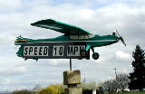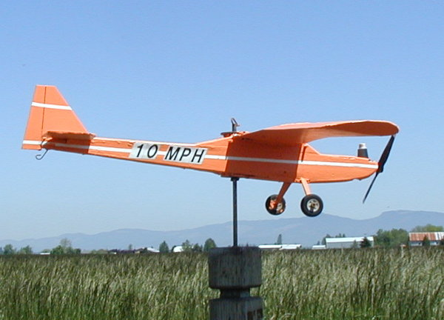

April 2008 May 2008

New Flight Tables
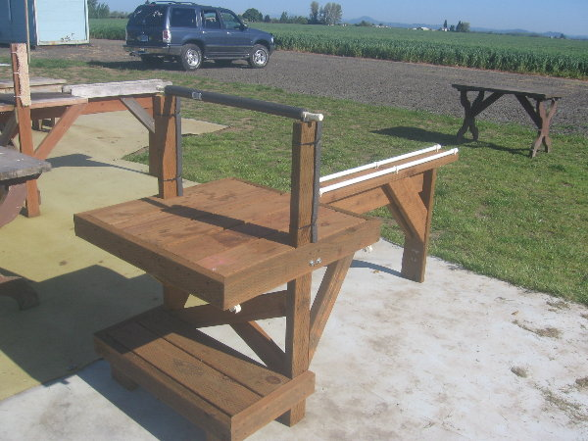
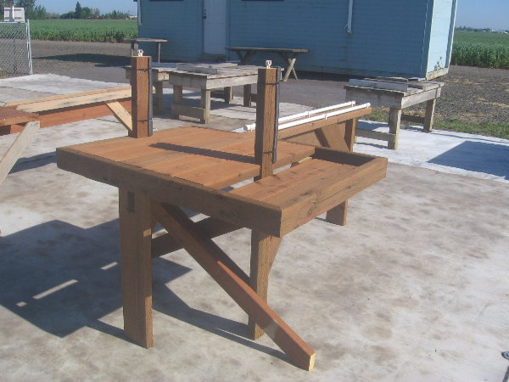
There are two styles. I have made patterns for the 2 that I have made. So reproductions should be fairly easy. The tray on the side was from comments made to me. The padded cpvc and clips on top are my idea.. they are to keep your plane on the table in our 30 mile an hour wind. I don't know if it works I haven't had a chance to try it. Also there are three moveable hooks for our receivers. I can purchase more, it looks like everyone is using them. I am open to any other ideas, as I am a carpenter by trade, changes are easy. Material cost are about $27. Jeff Engel

WITH THE WEEKDAY WARRIORS - May 2008

I think we’ll all agree that your Editor, Jim Corbett, has made this newsletter into a classy publication, but one problem has arisen. Jim runs everything through a computer program which weeds out words it doesn’t recognize and replaces them with ones it does. In my account of going to see Chuck Jenkins in the hospital last month, you read that, when I got there, he had “scampered”. Now we all know that Chuck Jenkins is far too dignified a fellow to “scamper” and indeed I had actually typed a fine old Irish verb which has an “r” in place of that “rn”. Aroo, aroo, the Editor’s program doesn’t recognize fine old Irish verbs, even one used by Himself, the Behan, in the title of a novel, thus we got “scamper’ instead of “scarper’. What ever would have happened if I’d used “absquatulate”? Well, we’re going to find out, aren’t we? (N.B. I did warn Jim that I was planting a bomb in this column, so he may well catch it.)
Speaking of Mr. Jenkins, he is not only out of the hospital but he’s back on the field with an oxygen tank slung over one shoulder and a new student under his wing. Wayne Wahrmund is newly retired and probably discovering, as I did, that it’s what he should have been doing all his life. Wayne’s got a Sig Kadet LT-40 with an 0.S. .46AX up front. 2.4 gig radio, too — is anybody buying anything else these days? They’ve already modified the LT-40 by replacing the wire main gear with a bent aluminum one. “Lands better’ is the verdict.
And while we are on the subject of the Sig Kadet series, Chick Foster has turned up with the little Seniorita which he built from a kit. I asked Chick how he had managed to find a kit to build and he told me he had to call Sig and get them to send one to Trump’s for him. He wasn’t quite sure they were still made. Power is a modest 0.S. .25, i.e. an engine appropriate to the model rather than the .52 people around here are prone to put in such machines. It is set up with a tailwheel landing gear and is flying just fine, thank you.
Frank Blain has been out with his Obsession which is pulled along by a Saito 1.80 four-stroke. Pulled along very well, according to Frank, who quite likes the aeroplane. He has his Yak 54 flying again after a crash necessitated some repairs. The engine was a Fuji 46, but that has been replaced by a DL50, a Chinese copy (literally) of the DA50. Frank is very modern, by the way. He is “outsourcing” his crashes. He let somebody else fly the Yak and that someone got it into a nice flat spin from which it could not be extricated.
Vein Wells has not yet joined the modern age; he’s still crashing them himself. Actually, it wasn’t anything Vern did. When the wing comes off your EasySport in flight, you don’t have a whole lot of options. Vern got no help from the mud; the nose was pretty bashed up.
There have been a lot of the usual people flying the usual models: Doug McWha with his Dual Ace and EasySport, Larry Nelson and his Tribute, about which he is only lukewarm, Pat Willis and his veteran Giles 202. (or is it 404? or am I getting it confused with old Martin airliners?) (Note: One of the engineers who worked on the design of those two Martins was Maxwell Bassett, the first guy to fly a gas model in competition.)
You knew that Scott Fellman was flying one Sceadu .50 helicopter and preparing another one to receive a scale Hughes 500 body once the Sceadu is flight-tested. (You knew that because you read it in this column.) Herewith an update: Everything’s set except the gyro.

This gyro seems to have ideas of what a gyro should do that differ markedly from Scott’s ideas of what a gyro should do. There the matter stands with the possibility that the offending gyro may just find itself out of a job, replaced by a more cooperative unit.

Your Editor has been flying small electrics when he’s not helping Doug mow the grass or get the sprinkler system set. up. One of them was a foam creation called a Park Shark which comes complete with fins and teeth. Jim says it is a bit underpowered, but adequate for boring holes in the sky on calmish days. It, quite literally, bit the dust on an awkward landing, but the light damage was entirely to the teeth. The slightly-larger Stinger has been flying as well as the biplane Wildfly. Jim also has a fairly large plane, built out of slabs of foam,

and this one resembles, a bit, the old ukie Ringmaster. He makes a flight or two with one, then pulls out another and so on until you have seen his whole stable. The Wildfly’s landing gear seems to hate this runway, no matter how closely Doug has it mowed.
You know your President is working on a new model and a scratch-built one at that. He’s been keeping its identity a deep, dark secret, but he did let slip that it is a common aeroplane, though not in the version he is building. My guess is that it is a Piper J-3, but the one with the Lenape Papoose engine instead of the Continental A65. Or the Spitfire on floats. Or the Bf 109T with the longer wing for carrier operations. I’ll check the spy satellites. One is bound to make passes over his neighborhood.

C.O'D.

Control-Line

Northwest
Regionals
May 23-24-25, 2008

Pacific Northwest control-line model aviation clubs would like to invite you to attend the 37th annual Northwest Control-Line Regionals on Memorial Day Weekend, May 23-24-25, 2008, at the Eugene Airport in Eugene, Oregon. Information and copies of the contest flyer, advance entry forms and a listing of local accommodations can be downloaded from http://flyinglines.org.
Further information on the Regionals can be obtained from the contest director, John Thompson, 2456 Quince St., Eugene, OR 97404, e-mail JohnT4051@aol.com, or phone (541) 689-5553.

Volunteers NEEDED

Setup starts Thursday May 22nd. 1 P.M. If you can assist in moving and positioning the MANY blocks and stanchions that are needed to have a well organized contest, then PLEASE email Mike Denlis or phone him at 541-807-9713 to get on the list.

--- That's All Folks ---


Eugene R/C Aeronauts
Newsletter Editor
1618 Gilham Rd.
Eugene, OR. 97401

MAY 2008

Name

Address
City, ST Zip



ERCA CLUB CONTACTS

President: Pat Willis – 543-8999 - p-willis@msn.com
Vice President: Mel Thompson - 746-5699 - met324@comcast.net
Sec/Treasurer: Al Barrington - 935-4960 - albarrington@msn.com
Groundskeeper: Doug McWha - 741-3326 – flyduke@comcast.net
Field Marshals: John Bowhan - 607-5752 - jbowhan@epud.net
Frank Blain, Jim Corbett, Bill Hollingsworth, Khoi Tran, Alan Wellentin
Newsletter Editor: Jim Corbett - 344-5022 - james.corbett@comcast.net

Newsletter ONLINE at: http://erca.home.comcast.net/%7Eerca/NL/ CURRENTNEWSLETTER.pdf

