EUGENE R/C AERONAUTS .
Volume 4, Issue 2 AMA #530 District 11 www.eugenerc.com February 2008 .
.
Club Mailing Address: Eugene R/C Aeronauts, PO Box 50034, Eugene, OR. 97405

News and Information

CORRECTION - Meeting date below is incorrect, the meeting is on Tuesday February 26th

Next CLUB Meeting – February 19, 7:00 pm at EWEB. Bring your dues if you have not already paid them. If you have a winter building project, bring it with you.

At the January Meeting – Khoi Tran did a presentation on retractable landing gear and showed off his camouflaged Corsair.

John Farkas showed a couple helicopters with a new computerized IR gyro stabilizer system.

Nick Speer showed his Showtime and another plane he was selling.

Pat Willis showed us his new conversion to 2.4 GHz for his Futaba radio.

25 members attended the January meeting.

PIZZA MEETING – Club approved having the March 2008 meeting at Papa’s Pizza on Coburg Road.

DUES TIME – 2008 is HERE, PLEASE pay your AMA and ERCA dues! You will get this Newsletter through March, then if you are not a current member it will stop arriving.
INDOOR FLYING – Al Peacock has found an indoor place for SMALL ELECTRIC and NON-MOTORIZED aircraft flying. The National Guard Armory on Scout Access Road off MLK Blvd is available most week days from 8 am - 5 pm on a first come basis. It is used by some basket ball players several times a week from 1 pm - 2:30 pm. A 59' x 96' space with aprox 24' ceiling. Talk to Mike Wiley at the Armory to get permission to fly.
CARL HENSON FIELD – It is still a bit wet. The runway was mowed January 25. Sand and fertilizer to be added this spring.

Attention All Pilots:
WINTER FLYING RULES
During November, December,
January, February
Saturday, Sunday & Wednesday
NO FLYING before 12:00 Noon.

BIG BIRD FLY-IN – March 1st, 2008. ERCA will extend an open invitation for the South Lane club to attend the Big Bird Fly-In.

NEWSLETTER NEEDS INPUT – Thank you John Farkas for your input.

I would like members to send me photos and a short write-up on any projects they are working on, or new aircraft. If you can’t email it to me, mail me a photo and a note.

Also if you have any building TIPS or TRICKS you would like to share, I would be glad to pass those along.

PLEASE
IF you have an EMAIL account,
PLEASE request your Newsletter via EMAIL.
STAMPS and PAPER
cost the Club (YOU) money.

WHATS NEW

Whats New at: http://www.eugenerc.com/

New "Khoi's Corner" page up and coming! Kevink@eugenerc.com
For more info, click here: http://www.eugenerc.com/khoi.php

We had the first installment of Khoi’s Corner LIVE! At the January meeting his presentation covered part one of a two part series on retractable landing gear. This month’s edition covered sport plane applications, mechanical and pneumatic. Next month Khoi will delve into scale applications.

FOR SALE - WANTED

Wanted - E-FLIGHT ELECTRAJET 33 " wing span - james.corbett@comcast.net

Gripes & Grumbles

Winter WOES -- Cold and windy!

KUDOS

Pat Willis thanks Al Barrington and Bill Hollingsworth for serving as officers in 2007.

TIPS & TECHNIQUES

From Bill Hollingsworth (Field/Safety Marshal)
The winter (snow?) season is a great time to cycle and check your batteries' condition. You should be going over ALL of the fasteners on your planes, checking for loose, stripped, or MISSING items, including all control surfaces and control rods; and don't forget your servos. Checking and tightening is "cheap insurance."

Treasurers Corner

2008 Jan 34 members have paid their dues, 1 new member has joined.

Meeting minutes are available at: http://erca.home.comcast.net/~erca/Meetings.hrml

AIRCRAFT FROM THE PAST - February 2008
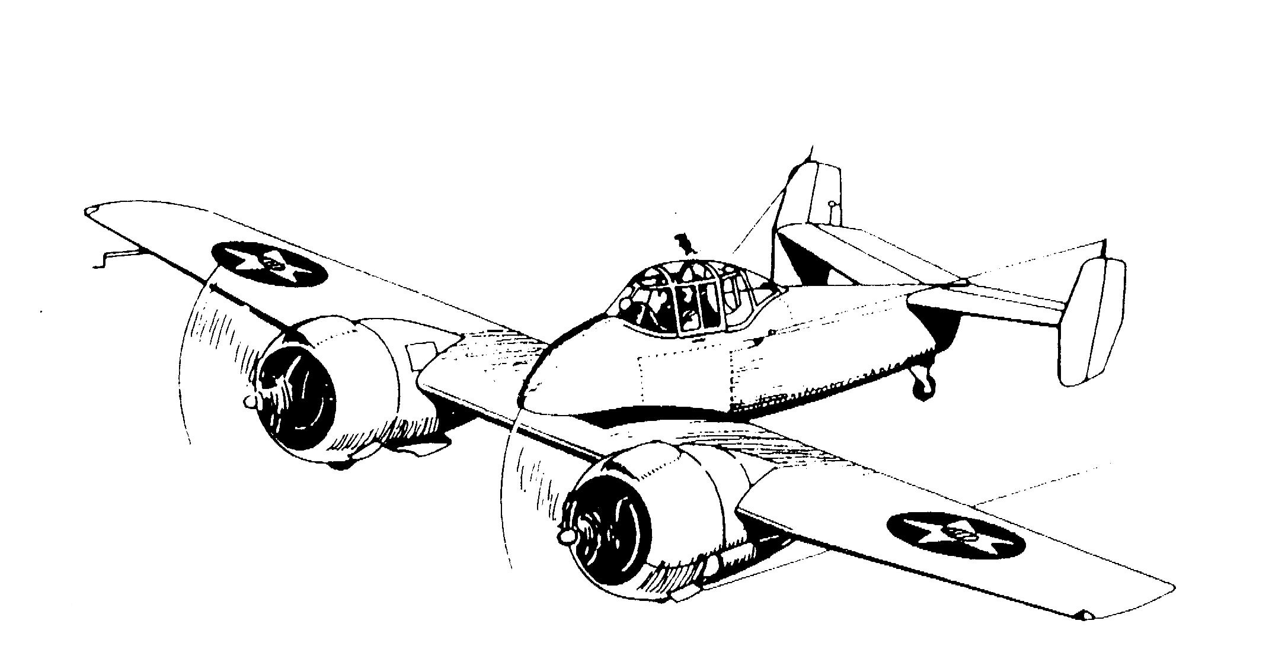

Why Didn’t They Just
Have Comet or Megow
or Cleveland Build It?

THE GRUMMAN XF5F-1 SKYROCKET

It is strange to find the words “Grumman” and "flop" in the same paragraph, let alone the same sentence, but there’s no denying it: The Grumman XF5F-1 Skyrocket was a flop. In 1938, the U.S. Navy issued a specification calling for a single-seat, twin-engined fighter to operate off aircraft carriers in defense of the fleet. It had to be able to climb very quickly and the Navy thought that the only way to do it was to have the two engines. Vought had a single-en-gined proposal, but even the engine was experimental. Still, the Navy gave Vought a contract for a prototype. Bell was in the race, too, with the XFL-1 - think of a tail-dragger P-39.
Grumman’s entry turned out to be an eye-catching machine whose fuselage extended no farther forward than the high point of the wing chord. There were twin fins on a dihedraled tailplane and a framed all-round-vision canopy. Framed, because they hadn’t yet learned to blow plastic bubbles. The intended engines had been the slim, twin-row, supercharged P&W R-1535s, but P&W dropped development of the blown version so Grumman was forced to use the Wright R-1820 a big, single-row engine of much greater frontal area. The Navy dithered on the armament specs, calling for everything from four .30s to four 23mm cannon. Each outer wing panel was required to have five little bombays each one housing two 5½-lb. “anti-aircraft” bombs, the quaint notion being that this fast-climbing interceptor would get above the densely-packed enemy bomber formations and shower them with the AA bombs. I’ll leave it to you to judge how effective that would have been.
Once testing began in early 1940, it became apparent that all was not well. Oh, it could climb - 4000 ft./min. to its nearest rival’s 2600 - but weight was up; visibility past those big nacelles was almost nil, airflow over that centersection was appalling; there were cylinder and oil cooling problems; and even the l.g. doors wouldn’t stay closed. The XF5F-1 grew a nose extending about three feet forward of the leading edge. It got redesigned and lengthened nacelles, wing fillets, and balanced rudders. It helped a little, but the Grumman was still slower than its single-engined rivals. Worse yet, the extended nose produced a very sudden stall, something predicted by NYU’s wind tunnel. Grumman was in full production of the F4F and wanted out of the Skyrocket project; the Navy was inclined to go along. The plane went down to Anacostia, D.C.s NAS, ostensibly for further testing, but more used as a station hack. In December of ‘44, on a flight to N.Y., the gear wouldn’t come down and the subsequent belly landing at NAS Floyd Bennett damaged the plane beyond repair. The station emergency-service crews used the hulk until the next Summer for practicing rescues from downed aircraft.

A second airframe was built for the Army as the XP-50, this one sporting a much longer nose to house the front component of a tricycle landing gear. Fairly early in the test, with more development apparently needed, one super-charger blew up, forcing test pilot Bob Hall to jump, and the Army to lose interest.
If Grumman threw up its hands in despair and the Navy shrugged it off, modelers and their kit manufacturers embraced the XF5F-1. The old John Pond old-time plans list has eleven entries for the Skyrocket, ranging from an 8” solid model to a 38” Ukie. Look back in the model rnags published since the war and you will find pictures and construction articles at regular intervals. Only a couple of years ago, Model Aviation had a photo of an XF5F-1 entered in an R/C fly-in. Cleveland put out this plane as one of its Masterkits and, as a kid, I longed to have one. The Masterkits were real works of art, intended solely for display, though presented as Rubber jobs. “Labor-intensive" is an understatement and they were far too heavy to fly, but boy, did they look good when finished! I never even asked for one for Christmas because I knew full well that they were beyond my modest capabilities. My generation is the one that was just reaching its teens when the war ended and you will find a few of us who will swear that the Skyrocket saw squadron service. It did indeed, but only in the Blackhawk comic books. Twenty years ago, I worked with a younger comic-book collector and he assured me that not only was the Blackhawk comic still being published, they were still flying Skyrockets. In fact, he was surprised to learn that there really had been such a plane.
Bell’s XFL-1 didn’t pan out, but Vought’s machine, after a great deal of development, did go into production. In fact, they built F4Us until 1952 and its engine, P&W’s R-2800 became, arguably, the finest large aircraft piston engine in history.
The drawing at the top is by the late Doug Rolfe who had a 2-page spread in Air Trails magazine every month. It was called “Air Progress” and, while the "progress” shown by some of the planes was open to question, they were all interesting and the drawings were always good.

C. O'D

Club Contacts

President: Pat Willis – 543-8999 - p-willis@msn.com
Vice President: Mel Thompson - 746-5699 - met324@comcast.net
Sec/Treasurer: Al Barrington - 935-4960 - albarrington@msn.com
Groundskeeper: Doug McWha - 741-3326 – flyd@clipper.net
Field Marshals: John Bowhan - 607-5752 - jbowhan@epud.net
Frank Blain, Jim Corbett, Bill Hollingsworth, Khoi Tran, Alan Wellentin
Newsletter Editor: Jim Corbett - 344-5022 - james.corbett@comcast.net

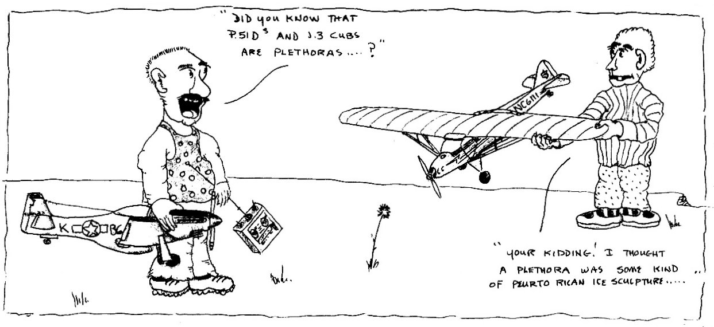

Building Projects

Raptor and Lepton - John Farkas

My winter project is outfitting a Raptor 50/V2 and a Lepton electric with a German made autopilot (HeliCommand). The gyro/optical sensor has three gyros (two for the cyclic and one for the tail) plus a downward looking optical infrared sensor. The gyros provide the level flight statbilisation; the optical unit "locks" the heli to hover in one spot relative to the ground the sensor "sees" at the moment of activation. From your Tx you can chose three options: to disable the unit, to use only the three gyros or to use the gyros+the opticall sensor. The system is active when the right stick and the rudder stick are in neutral (centered). If you move the sticks off neutral, you take over the driving. You will always maintain throttle control so you can move up/down with the unit active.

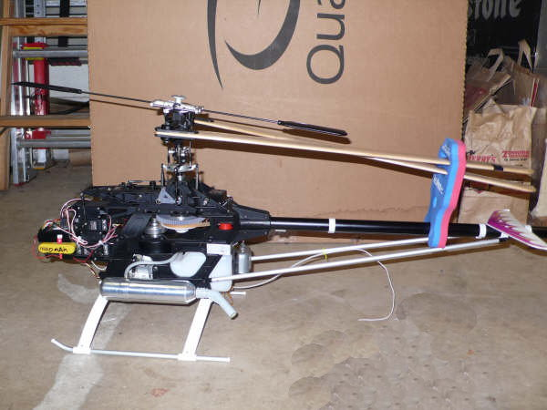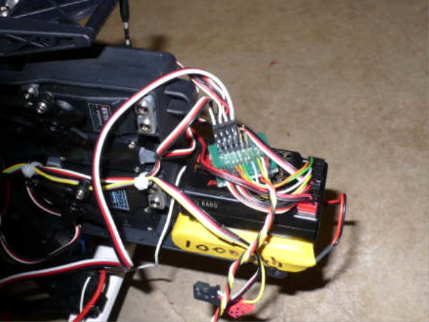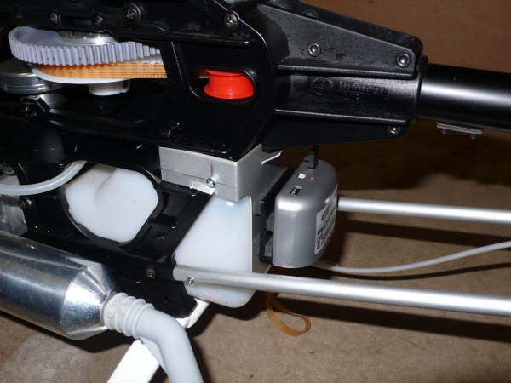

The Raptor - The close-up on the front show the Rx and the circuit board "brain" of the HeliCommand on top of the Rx. The close-up of the rear shows the gray gyro/optical sensor attached to the back of the fuel tank.

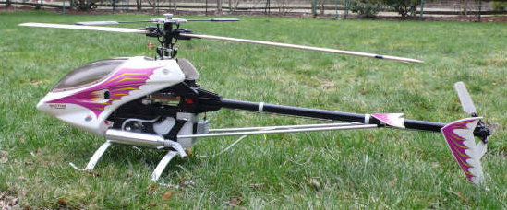
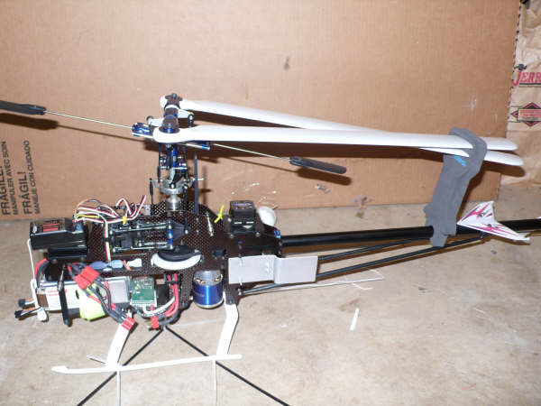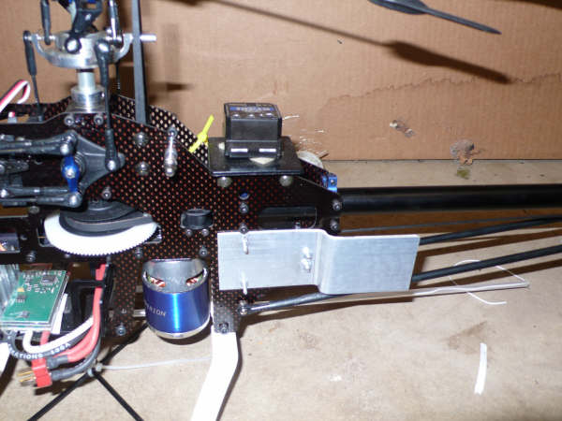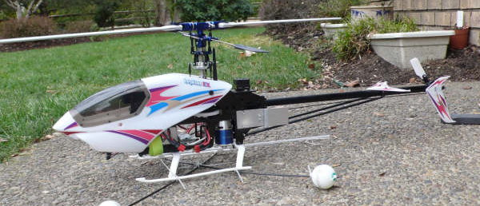

The Lepton - The second photo shows the kind of plate one has to fabricate to place the gyro/optical unit in a proper location. The lens (eye) of the optical sensor should have a totally unobstructed view looking down from the heli - a spot hard to find on most helis.

If you have any questions contact me at farkas36@hotmail.com I check my e-mail frequently. Or call me at 896-9239. --- John

This can be viewed ONLINE at http://erca.home.comcast.net/~erca/NL/ERCA_NL_Feb08.pdf

--- That’s All Folks ---

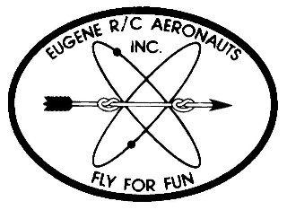
Eugene R/C Aeronauts
Newsletter Editor
1618 Gilham Rd.
Eugene, OR. 97401

FEB 2008

Name
Address
City, ST Zip

___________________________Renewing Current Member_____________________________

INVOICE FOR 2008 MEMBERSHIP - EUGENE R/C AERONAUTS

Please fill in the following information and send back with your Dues Remittance

Member Name __________________________________________________________________

2008 AMA Membership No.________________________

I certify that I have paid my 2008 AMA Dues. Initial _________

Member Address _______________________________________________________________

Member Phone No. __________________________

Member Email Address __________________________________________________________

Newsletter Preference: ____ Email ____ Regular Mail ____ Do not need to receive newsletter

Please enclose your check for $ 60.00 as a current member renewing for 2008 and

Mail to: Eugene R/C Aeronauts, PO Box 50034, Eugene, Or. 97405.

Or bring this INVOICE and $60.00 to the February Meeting.

